Let, X is an arithmetic expression written in infix notation. This algorithm finds the equivalent postfix expression Y.

1. Push “(“onto Stack, and add “)” to the end of X.
2. Scan X from left to right and repeat Step 3 to 6 for each element of X until the Stack is empty.
3. If an operand is encountered, add it to Y.
4. If a left parenthesis is encountered, push it onto Stack.
5. If an operator is encountered ,then:
   1. Repeatedly pop from Stack and add to Y each operator (on the top of Stack) which has the same precedence as or higher precedence than operator.
   2. Add operator to Stack.  
      [End of If]
6. If a right parenthesis is encountered ,then:
   1. Repeatedly pop from Stack and add to Y each operator (on the top of Stack) until a left parenthesis is encountered.
   2. Remove the left Parenthesis.  
      [End of If]  
      [End of If]
7. END.

Infix Expression: **A+ (B*C-(D/E^F)*G)*H**, where **^** is an exponential operator.

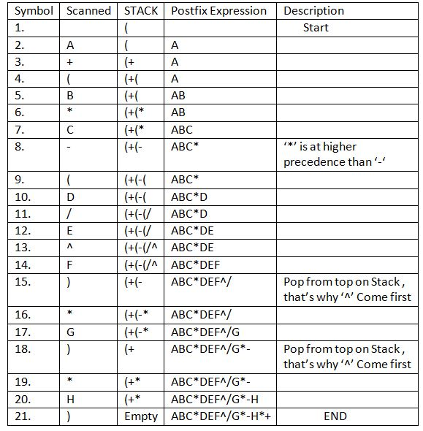

**Resultant Postfix Expression: ABC*DEF^/G*-H*+**

<https://www.geeksforgeeks.org/stack-set-4-evaluation-postfix-expression/>

<https://www.includehelp.com/c/infix-to-postfix-conversion-using-stack-with-c-program.aspx>